PML00100 – SALES TAX LOOKUP

USER INTERFACE:
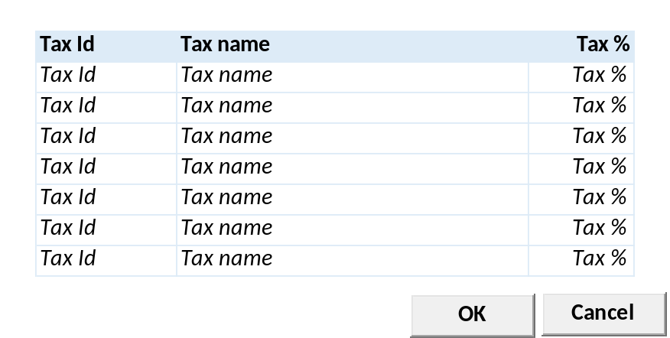

INPUT PARAMETER
Test
- COMPANY_ID
Company Id dari Login User

- USER_ID
Login User

BUTTON DEFINITION
Test
- OK
Tombol untuk mensubmit data yang terpilih ke form pemanggil
- Cancel
Tombol untuk membatalkan/menutup lookup

OUTPUT
Test

ROLES
Test
- Program ini tidak punya pengaturan hak akses sendiri, hak akses mengikut pada form pemanggil

INITIAL PROCESS
Test
- None

DISPLAY PROCESS
Test
Load Sales Tax Lookup List:

EXEC RSP_GS_GET_SALES_TAX_LIST @CCOMPANY_ID, @CUSER_LOGIN_ID

- Dimana Set:
  - @COMPANY_ID = [COMPANY_ID]
  - @CUSER_ID = [CUSER_ID]
- Result:
  - CCOMPANY_ID
  - CTAX_ID
  - CTAX_NAME
  - CDESCRIPTION
  - NTAX_PERCENTAGE
  - IROUNDED
  - CGLACCOUNT_NO
  - CGLACCOUNT_NAME
  - LACTIVE
  - CACTIVE_BY
  - DACTIVE_DATE
  - CINACTIVE_BY
  - DINACTIVE_DATE
  - CCREATE_BY
  - DCREATE_DATE
  - CUPDATE_BY
  - DUPDATE_DATE
- Definisi Column: (Single Selection)
  - "Tax Id"
    - Field: [CTAX_ID]
    - Label
  - "Tax Name"
    - Field: [CTAX_NAME]
    - Label
  - "Tax %"
    - Field: [NTAX_PERCENTAGE]
    - Label

- Definisi Button:
  - OK
    - Onclick:
      - Validasi:
        - Harus ada 1 row yang terpilih, jika tidak tampilkan error message “Please select Sales Tax”
      - Kirim semua informasi Tax yang terpilih ke form pemanggil:
        - CCOMPANY_ID
        - CTAX_ID
        - CTAX_NAME
        - NTAX_PERCENTAGE
      - Tutup form lookup
  - Cancel
    - Onclick: tutup form lookup

PML00200 – UNIT CHARGES LOOKUP

USER INTERFACE:
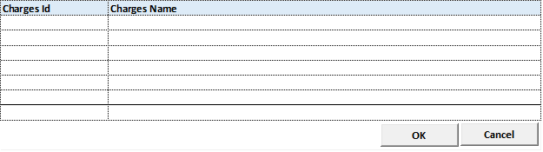

INPUT PARAMETER
Parameter Name | Description
CCOMPANY_ID | Company Id
CPROPERTY_ID | Property ID
CCHARGES_TYPE_ID | Charges Type Id
CUSER_ID | User Id
CTAXABLE_TYPE | Taxable Type (0=All, 1=Taxable, 2=Non Taxable)
CACTIVE_TYPE | Active Type (0=All, 1=Active, 2=Inactive)
CTAX_DATE | Tax Date
LACCRUAL | Accrual Flag [CR17]

OUTPUT PARAMETER
Parameter Name | Description
CCOMPANY_ID
CPROPERTY_ID
CCHARGES_TYPE
CCHARGES_TYPE_DESCR
CCHARGES_ID
CCHARGES_NAME
LTAXABLE
LWITHHOLDING_TAX
CWITHHOLDING_TAX_ID
CWITHHOLDING_TAX_NAME
COTHER_TAX_ID
COTHER_TAX_NAME
NOTHER_TAX_PCT
CUOM
CTAX_EXEMPTION_CODE
CTAX_EXEMPTION_NAME
NTAX_EXEMPTION_PCT
LACTIVE
CCREATE_BY
DCREATE_DATE
CUPDATE_BY
DUPDATE_DATE
CCOMPANY_ID
CPROPERTY_ID
CCHARGES_TYPE
CCHARGES_TYPE_DESCR
CCHARGES_ID
CCHARGES_NAME
LTAXABLE
LWITHHOLDING_TAX
CWITHHOLDING_TAX_ID
CWITHHOLDING_TAX_NAME
COTHER_TAX_ID
COTHER_TAX_NAME
<CR14>
CINVGRP_CODE | Invoice Group Code
CINVGRP_NAME | Invoice Group Name
</CR14>

BUTTON DEFINITION
Test
- OK
Tombol untuk mensubmit data yang terpilih ke form pemanggil
- Cancel
Tombol untuk membatalkan/menutup lookup

OUTPUT[CR09]
Parameter Name | Description
CPROPERTY_ID
CCHARGES_TYPE
CCHARGES_TYPE_DESCR
CCHARGES_ID
CCHARGES_NAME
LTAXABLE
LACTIVE
LWITHHOLDING_TAX
CWITHHOLDING_TAX_ID
CWITHHOLDING_TAX_NAME
COTHER_TAX_ID
COTHER_TAX_NAME
NOTHER_TAX_PCT
CUOM
LTAX_EXEMPTION
CTAX_EXEMPTION_CODE
NTAX_EXEMPTION_PCT

ROLES
Test
- Program ini tidak punya pengaturan hak akses sendiri, hak akses mengikut pada form pemanggil

INITIAL PROCESS
Test
- None

DISPLAY PROCESS
Test
Load Unit Charges Lookup List:

EXEC RSP_PM_GET_CHARGES_TYPE_LIST @CCOMPANY_ID, @CPROPERTY_ID, @CCHARGE_TYPE_ID, @CUSER_LOGIN_ID, @CTAXABLE_TYPE, @CACTIVE_TYPE, @CTAX_DATE [CR09]

- Dimana Set:
  - @COMPANY_ID = [COMPANY_ID]
  - @CPROPERTY_ID = [Selected Property Id]
  - @CUSER_LOGIN_ID = [USER_ID] [CR09]
  - @CTAXABLE_TYPE = Selected Taxable Type [CR09]
  - @CACTIVE_TYPE = Selected Active Type [CR09]
  - @CTAX_DATE = Selected Tax Date [CR09]

- Definisi Column: (Single Selection)
  - "Charges Id"
    - Field: [CCHARGES_ID]
    - Label
  - "Charges Name"
    - Field: [CCHARGES_NAME]
    - Label

- Definisi Button:
  - OK
    - Onclick:
      - Validasi:
        - Harus ada 1 row yang terpilih, jika tidak tampilkan error message “Please select Unit Charges”
      - Kirim semua informasi Tax yang terpilih ke form pemanggil:
        - CCHARGES_ID
        - CCHARGES_NAME
        - CCHARGES_TYPE
        - CCHARGES_TYPE_DESCR
      - Tutup form lookup
  - Cancel
    - Onclick: tutup form lookup
- Tambah Output:

CR14 CINVGRP_CODE, CINVGRP_NAME

PML00300 – SUPERVISOR LOOKUP

USER INTERFACE:
[CR01]
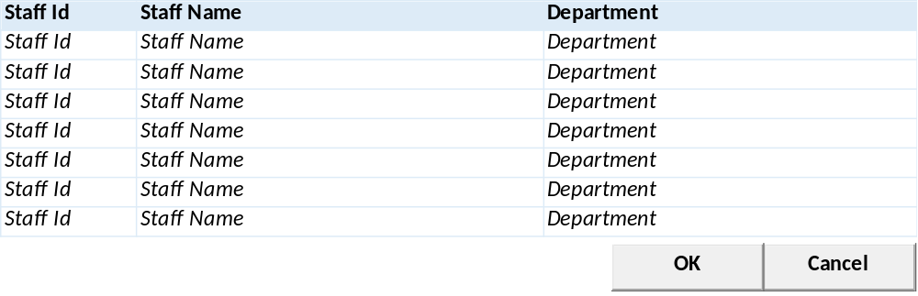

INPUT PARAMETER
Test
- CCOMPANY_ID
Company Id dari Login User

- CPROPERTY_ID
Login User

BUTTON DEFINITION
Test
- OK
Tombol untuk mensubmit data yang terpilih ke form pemanggil
- Cancel
Tombol untuk membatalkan/menutup lookup

OUTPUT
Test

ROLES
Test
- Program ini tidak punya pengaturan hak akses sendiri, hak akses mengikut pada form pemanggil

INITIAL PROCESS
Test
- None

DISPLAY PROCESS
Test
Load Supervisor Lookup List:

EXEC RSP_PM_GET_SUPERVISOR_LOOKUP_LIST @CCOMPANY_ID, @CPROPERTY_ID, @CUSER_LOGIN_ID, [CR24] @LINCLUDE_ADMIN, @LINCLUDE_MANAGEMENT

- Dimana Set:
  - @COMPANY_ID = [COMPANY_ID]
  - @CPROPERTY_ID = [Selected Property Id]
  - @CDEPT_CODE = Selected Department Code
  - @CUSER_LOGIN_ID = User Login Id

- Definisi Column: (Single Selection)
  - "Supervisor Id"
    - Field: [CSUPERVISOR]
    - Label
  - "Supervisor Name"
    - Field: [CSUPERVISOR_NAME]
    - Label
  - "Department"
    - Field: CDEPT_NAME (CDEPT_CODE)
    - Label
[CR24]
  - "Type"
    - Field: CTYPE_DESCR (CTYPE)
    - Label
[CR24/]

- Definisi Button:
  - OK
    - Onclick:
      - Validasi:
        - Harus ada 1 row yang terpilih, jika tidak tampilkan error message “Please select Supervisor”
      - Kirim semua informasi Tax yang terpilih ke form pemanggil:
        - CSUPERVISOR
        - CSUPERVISOR_NAME
        - CDEPT_CODE
        - CDEPT_NAME
[CR24]
        - CTYPE
        - CTYPE_DESCR
[CR24/]
      - Tutup form lookup
  - Cancel
    - Onclick: tutup form lookup

PML00400 – UTILITY CHARGES LOOKUP

USER INTERFACE:

INPUT PARAMETER [CR09]
Parameter Name | Description
CCOMPANY_ID | Company Id
CPROPERTY_ID | Property ID
CCHARGES_TYPE_ID | Charges Type Id
CUSER_ID | User Id
CTAXABLE_TYPE | Taxable Type (0=All, 1=Taxable, 2=Non Taxable)
CACTIVE_TYPE | Active Type (0=All, 1=Active, 2=Inactive)
CTAX_DATE | Tax Date

BUTTON DEFINITION
Test
- OK
Tombol untuk mensubmit data yang terpilih ke form pemanggil
- Cancel
Tombol untuk membatalkan/menutup lookup

OUTPUT [CR09]
Parameter Name | Description
CPROPERTY_ID
CCHARGES_TYPE
CCHARGES_TYPE_DESCR
CCHARGES_ID
CCHARGES_NAME
LTAXABLE
LACTIVE
LWITHHOLDING_TAX
CWITHHOLDING_TAX_ID
CWITHHOLDING_TAX_NAME
COTHER_TAX_ID
COTHER_TAX_NAME
NOTHER_TAX_PCT
CUOM
LTAX_EXEMPTION
CTAX_EXEMPTION_CODE
NTAX_EXEMPTION_PCT

ROLES
Test
- Program ini tidak punya pengaturan hak akses sendiri, hak akses mengikut pada form pemanggil

INITIAL PROCESS
Test
- None

DISPLAY PROCESS
Test
Load Utility Charges Lookup List:

EXEC RSP_PM_GET_CHARGES_UTILITY_LIST @CCOMPANY_ID, @CPROPERTY_ID, @CCHARGE_TYPE_ID, @CUSER_LOGIN_ID, @CTAXABLE_TYPE, @CACTIVE_TYPE, @CTAX_DATE [CR09]

- Dimana Set:
  - @COMPANY_ID = [COMPANY_ID]
  - @CPROPERTY_ID = [Selected Property Id]
  - @CCHARGE_TYPE_ID = Selected Charges Type Id
  - @CUSER_LOGIN_ID = [USER_ID] [CR09]
  - @CTAXABLE_TYPE = Selected Taxable Type [CR09]
  - @CACTIVE_TYPE = Selected Active Type [CR09]
  - @CTAX_DATE = Selected Tax Date [CR09]

- Definisi Column: (Single Selection)
  - "Charges Id"
    - Field: [CCHARGES_ID]
    - Label
  - "Charges Name"
    - Field: [CCHARGES_NAME]
    - Label

- Definisi Button:
  - OK
    - Onclick:
      - Validasi:
        - Harus ada 1 row yang terpilih, jika tidak tampilkan error message “Please select Unit Charges”
      - Kirim semua informasi Tax yang terpilih ke form pemanggil:
        - CCHARGES_ID
        - CCHARGES_NAME
      - Tutup form lookup
  - Cancel
    - Onclick: tutup form lookup

PML00500 – SALESMAN LOOKUP

USER INTERFACE:
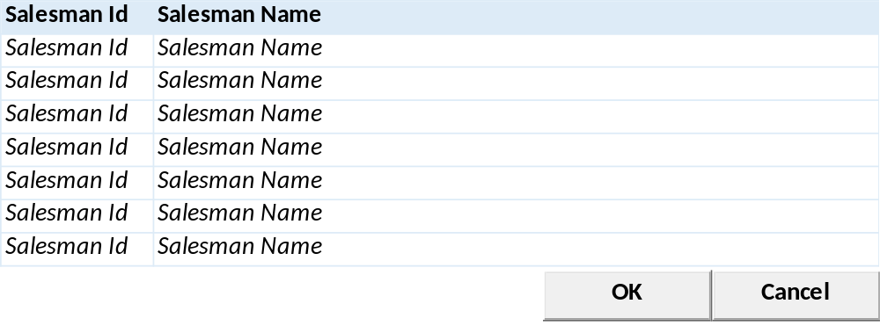

INPUT PARAMETER
Test
- CCOMPANY_ID
Company Id dari Login User

- CPROPERTY_ID
Login User

BUTTON DEFINITION
Test
- OK
Tombol untuk mensubmit data yang terpilih ke form pemanggil
- Cancel
Tombol untuk membatalkan/menutup lookup

OUTPUT
Test

ROLES
Test
- Program ini tidak punya pengaturan hak akses sendiri, hak akses mengikut pada form pemanggil

INITIAL PROCESS
Test
- None

DISPLAY PROCESS
Test
Load Salesman Lookup List:

EXEC RSP_PM_GET_SALESMAN_LIST @CCOMPANY_ID, @CPROPERTY_ID, @CUSER_LOGIN_ID, [CR16] @LACTIVE

- Dimana Set:
  - @COMPANY_ID = [COMPANY_ID]
  - @CPROPERTY_ID = [Selected Property Id]
  - @CUSER_LOGIN_ID = User Login Id

- Definisi Column: (Single Selection)
  - Salesman Id"
    - Textbox
    - Display = CSALESMAN_ID
  - "Salesman Name"
    - Textbox
    - Display = CSALESMAN_NAME
- Definisi Button:
  - OK
    - Onclick:
      - Validasi:
        - Harus ada 1 row yang terpilih, jika tidak tampilkan error message “Please select Salesman”
      - Kirim semua informasi Tax yang terpilih ke form pemanggil:
        - CSALESMAN_ID
        - CSALESMAN_NAME
      - Tutup form lookup
  - Cancel
    - Onclick: tutup form lookup

PML00600 – TENANT LOOKUP

USER INTERFACE:
[CR02]
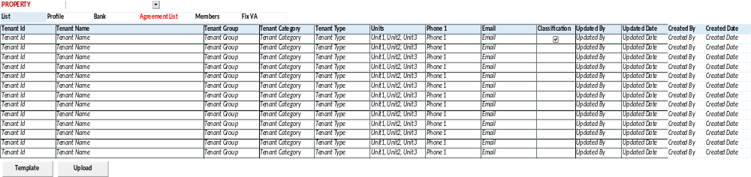

INPUT PARAMETER
Test
- CCOMPANY_ID
Company Id dari Login User

- CPROPERTY_ID
Login User

- CCUSTOMER_TYPE
Customer Type
01 - Tenant
02 - Contractor

BUTTON DEFINITION
Test
- OK
Tombol untuk mensubmit data yang terpilih ke form pemanggil
- Cancel
Tombol untuk membatalkan/menutup lookup

OUTPUT
Test

ROLES
Test
- Program ini tidak punya pengaturan hak akses sendiri, hak akses mengikut pada form pemanggil

INITIAL PROCESS
Test
- None

DISPLAY PROCESS
Test
Load Tenant Lookup List:

EXEC RSP_PM_GET_TENANT_LIST @CCOMPANY_ID, @CPROPERTY_ID, @CCUSTOMER_TYPE, @CUSER_LOGIN_ID

- Dimana Set:
  - @COMPANY_ID = [COMPANY_ID]
  - @CPROPERTY_ID = [Selected Property Id]
  - @CCUSTOMER_TYPE = 01 – Tenant / 02 - Contractor
  - @CUSER_LOGIN_ID = User Login Id

- Definisi Column: (Single Selection)
  - "Tenant Id"
    - Textbox
    - Field = CTENANT_ID

  - "Tenant Name"
    - Textbox
    - Field = CTENANT_NAME

  - "Tenant Group"
    - Textbox
    - Field = CTENANT_GROUP_NAME

  - "Tenant Category"
    - Textbox
    - Field = CTENANT_CATEGORY_NAME

  - "Tenant Type"
    - Textbox
    - Field = CTENANT_TYPE_NAME

  - "Units"
    - Textbox
    - Field = CUNIT_NAME

  - "Phone 1"
    - Textbox
    - Field = CPHONE1

  - "Email"
    - Textbox
    - Field = CEMAIL
- Definisi Button:
  - OK
    - Onclick:
      - Validasi:
        - Harus ada 1 row yang terpilih, jika tidak tampilkan error message “Please select Tenant”
      - Kirim semua informasi Tenant yang terpilih ke form pemanggil:
        - CTENANT_ID
        - CTENANT_NAME
        - CTENANT_GROUP_NAME
        - CTENANT_CATEGORY_NAME
        - CTENANT_TYPE_NAME
        - CUNIT_NAME
        - CPHONE1
        - CEMAIL
        - CCUSTOMER_TYPE
        - CCUSTOMER_TYPE_NAME
        - CR11 CPAYMENT_TERM_CODE
        - CR11 CCURENCY_CODE
        - CR11 CTAX_TYPE
        - CR11 LTAXABLE
        - CR11 CTAX_ID
        - CR11 CTAX_NAME
        - CR11 NTAX_PCT

      - Tutup form lookup
  - Cancel
    - Onclick: tutup form lookup

PML00700 – DISCOUNT LOOKUP

USER INTERFACE:
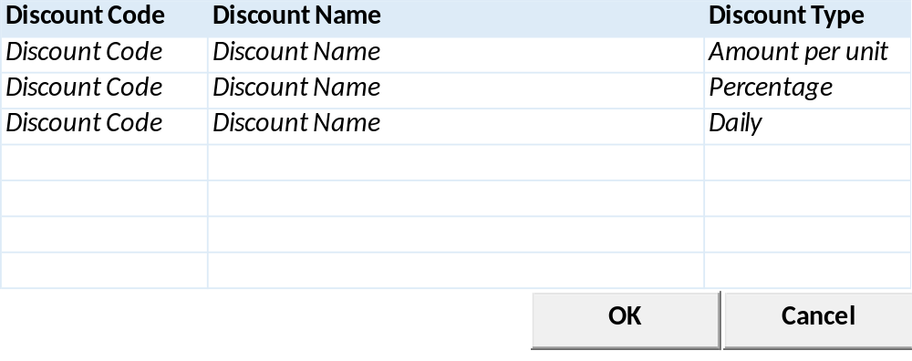

INPUT PARAMETER
Test
- CCOMPANY_ID
Company Id dari Login User

- CPROPERTY_ID
Login User

BUTTON DEFINITION
Test
- OK
Tombol untuk mensubmit data yang terpilih ke form pemanggil
- Cancel
Tombol untuk membatalkan/menutup lookup

OUTPUT
Test

ROLES
Test
- Program ini tidak punya pengaturan hak akses sendiri, hak akses mengikut pada form pemanggil

INITIAL PROCESS
Test
- None

DISPLAY PROCESS
Test
Load Discount List:

EXEC RSP_PM_GET_DISCOUNT_LIST @CCOMPANY_ID, @CPROPERTY_ID, @CCHARGES_TYPE_CODE, @CUSER_LOGIN_ID

- Dimana Set:
  - @COMPANY_ID = [COMPANY_ID]
  - @CPROPERTY_ID = [Selected Property Id]
  - Selected Charges Type Code
  - @CUSER_LOGIN_ID = User Login Id

- Definisi Column: (Single Selection)
  - "Discount Code"
    - Textbox
    - Field = CDISCOUNT_CODE
  - "Discount Name"
    - Textbox
    - Field = CDISCOUNT_NAME
  - "Discount Type"
    - Textbox
    - Field = CDISCOUNT_TYPE

- Definisi Button:
  - OK
    - Onclick:
      - Validasi:
        - Harus ada 1 row yang terpilih, jika tidak tampilkan error message “Please select Discount”
      - Kirim semua informasi Tax yang terpilih ke form pemanggil:
        - CDISCOUNT_CODE
        - CDISCOUNT_NAME
        - CDISCOUNT_TYPE
      - Tutup form lookup
  - Cancel
    - Onclick: tutup form lookup

PML00800 – AGREEMENT LOOKUP

USER INTERFACE: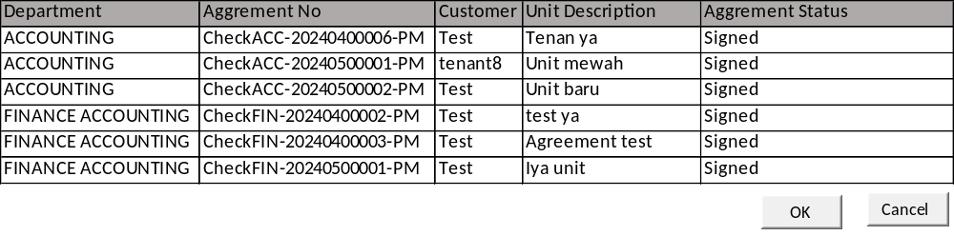

INPUT PARAMETER
Parameter Name | Description
CCOMPANY_ID | Company ID
CPROPERTY_ID | Property ID
CDEPT_CODE | Department Code
CAGREEMENT_STATUS | Agreement Status
CLANGUAGE_ID | Language ID
CTRANS_CODE | Transaction Code CR12
CREF_NO | Ref No CR12
CTENANT_ID | Tenant ID CR12
CBUILDING_ID | Building ID CR12
CTRANS_STATUS | Trans Status (00,01,02) CR12
CUSER_ID CR15 | User Id

BUTTON DEFINITION
Test
- OK
Tombol untuk mensubmit data yang terpilih ke form pemanggil
- Cancel
Tombol untuk membatalkan/menutup lookup

OUTPUT
CR12 | Test
CREC_ID
CFLOW_ID
CTRANS_CODE
CTRANSACTION_NAME
CDEPT_CODE
CDEPT_NAME
CREF_NO
CREF_DATE
CTENANT_ID
CTENANT_NAME
CUNIT_DESCRIPTION
CBUILDING_ID
CBUILDING_NAME
CAGREEMENT_STATUS
CAGREEMENT_STATUS_NAME
CLOI_REF_NO
CSALESMAN_ID
CSALESMAN_NAME

ROLES
Test
- Program ini tidak punya pengaturan hak akses sendiri, hak akses mengikut pada form pemanggil

INITIAL PROCESS
Test
- None

DISPLAY PROCESS
Test
Load Agreement List:

EXEC RSP_PM_GET_AGGREMENTNO_LIST @CCOMPANY_ID,
@CPROPERTY_ID,@CDEPT_CODE,@CAGGR_STTS,@CLANG_ID,
@CTRANS_CODE, @CREF_NO,@CTENANT_ID,@CBUILDING_ID, @CTRANS_STATUS, @CUSER_ID CR15

- Dimana Set:
  - @COMPANY_ID = [COMPANY_ID]
  - @CPROPERTY_ID = [Selected Property Id]
  - @CDEPT_CODE = Selected Dept Code
  - @CAGGR_STTS = Selected Aggrement Status
  - @CLANG_ID = [LANG_ID]
  - @CTRANS_CODE = [Selected Trans Code]
  - @CREF_NO = Selected Ref No
  - @CTENANT_ID = Selected Tenant Id
  - @CBUILDING_ID = Selected Building Id
  - @CTRANS_STATUS = Selected Trans Status
  - @CUSER_ID = [CUSER_ID] CR15

- Definisi Column: (Single Selection)
  - "Department"
    - Textbox
    - Field = CDEPT_NAME
  - "Aggrement No"
    - Textbox
    - Field = CREF_NO
  - "Customer"
    - Textbox
    - Field = CTENANT_NAME
  - "Unit Description"
    - Textbox
    - Field = CUNIT_DESCRIPTION
  - “Aggrement Status"
    - Textbox
    - Field = CAGREEMENT_STATUS_NAME
- Definisi Button:
  - OK
    - Onclick:
      - Validasi:
        - Harus ada 1 row yang terpilih, jika tidak tampilkan error message “Please select Agreement”
      - Kirim semua informasi yang terpilih ke form pemanggil:
        - CDEPT_CODE
        - CDEPT_NAME
        - CREF_NO
        - CREF_DATE
        - CTENANT_ID
        - CTENANT_NAME
        - CAGREEMENT_STATUS
        - CAGREEMENT_STATUS_NAME
      - Tutup form lookup
  - Cancel
    - Onclick: tutup form lookup

PML00900 – PM TRANSACTION LOOKUP

USER INTERFACE

CR25
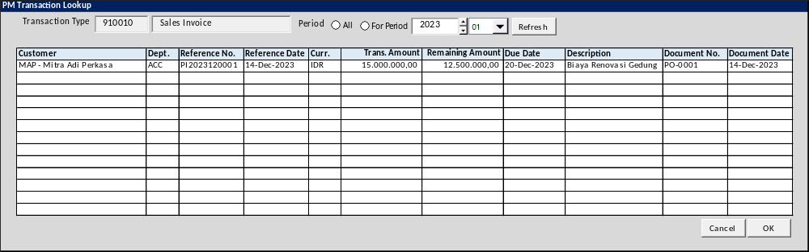

INITIAL VERSION
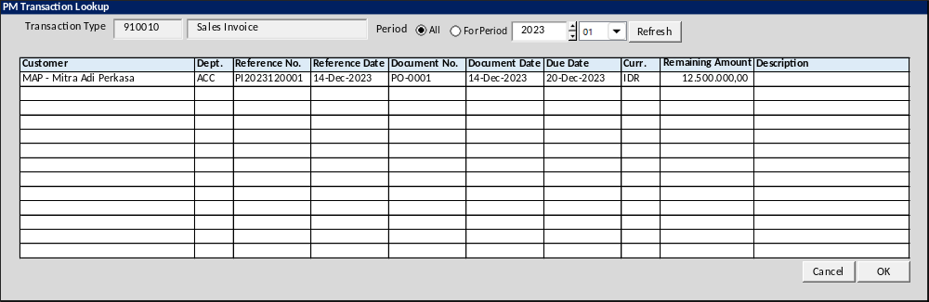

BUTTON DEFINITION
Button Name | Action
Refresh | Jalankan REFRESH PROCESS
OK | Jalankan SELECT DATA PROCESS
Cancel | Tutup Form

INPUT PARAMETER
Parameter Name | Description
CCOMPANY_ID | Company ID
CPROPERTY_ID | Property ID
CDEPT_CODE | Department Code
CTENANT_ID | Tenant ID
CUSER_ID | Login User ID
CTRANS_CODE | Transaction Code
CTRANS_NAME | Transaction Name
LHAS_REMAINING | Include Transaction with Remaining Amount Flag
LNO_REMAINING | Include Transaction with No Remaining Amount Flag
CLANGUAGE_ID | Language ID
CCURRENCY_CODE | Currency Code

OUTPUT PARAMETER
Parameter Name | Description
CPROPERTY_NAME | Property Name
CDEPT_CODE | Department Code
CDEPT_NAME | Department Name
CTRANS_CODE | Transaction Code
CREF_NO | Reference No
NTOTAL_REMAINING | Total Remaining Amount
CREC_ID | Record ID
CREF_DATE | Reference Date
CREF_PRD | Reference Period
CTENANT_ID | Customer ID
CTENANT_NAME | Customer Name
CDOC_NO | Document No.
CDOC_DATE | Document Date
CCURRENCY_CODE | Currency Code
CCURRENCY_NAME | Currency Name
CTRANS_STATUS | Transaction Status
CTRANS_STATUS_NAME | Transaction Status Name
CTRANS_DESC | Transaction Description
CDUE_DATE | Due Date
NLTOTAL_REMAINING | Total Remaining in Local Currency
NBTOTAL_REMAINING | Total Remaining in Base Currency
NAP_REMAINING | AP Remaining in Transaction Currency
NLAP_REMAINING | AP Remaining in Local Currency
NBAP_REMAINING | AP Remaining in Base Currency
NTAX_REMAINING | Tax Remaining in Transaction Currency
NLTAX_REMAINING | Tax Remaining in Local Currency
NBTAX_REMAINING | Tax Remaining in Base Currency
NLBASE_RATE | Base Rate in Local Currency
NLCURRENCY_RATE | Currency Rate in Local Currency
NBBASE_RATE | Base Rate in Base Currency
NBCURRENCY_RATE | Currency Rate in Base Currency
NTAX_BASE_RATE | Tax Base Rate
NTAX_CURRENCY_RATE | Tax Currency Rate
<CR13>
NWH_TAX | WH Tax
NWH_TAX_REMAINING | WH Tax Remaining
</CR13>
<CR25>
NTRANS_AMOUNT | Transaction Amount
</CR25>

INITIAL PROCESS
Test
- Jalankan RSP_GS_GET_PERIOD_YEAR_RANGE dengan parameter, simpan hasil ke VAR_GSM_PERIOD
  - CCOMPANY_ID
  - ‘’ (Empty String)
  - ‘’ (Empty String)

DISPLAY PROCESS

FIELD DEFINITION
Name | Field | Type | Validation
Transaction Type | CTRANS_CODE | Textbox, disabled
 | CTRANS_NAME | Textbox, disabled
Period |  | Option button  Option value  A=All  P=For Period (Default) | On value changed  - IF selected Value=A THEN Enable Year and Period Combobox ELSE Disable Year and Period combobox
Year |  | Spinner  - Minimum Value = VAR_GSM_PERIOD.IMIN_YEAR  - Minimum Value = VAR_GSM_PERIOD.IMAX_YEAR  - Stepping value = 1  Set Default selected value = Current Year
Period |  | Combobox  Isi combo box value dengan  01 s/d 12  Set Default selected value = Current Month

REFERENCE NO. GRID DEFINITION
Name | Field | Type | Validation
Customer | CTENANT_ID – CTENANT_NAME | Label
Dept. | CDEPT_CODE | Label
Reference No. | CREF_NO | Label
Reference Date | CREF_DATE | Label
<CR25>
Document No. | CDOC_NO | Label
Document Date | CDOC_DATE | Label
Due Date | CDUE_DATE | Label
Curr. | CCURRENCY_CODE | Label
Remaining Amount | NTOTAL_REMAINING | Label
Description | CTRANS_DESC | Label
Curr. | CCURRENCY_CODE | Label
Trans. Amount | NTRANS_AMOUNT | Label
Remaining Amount | NTOTAL_REMAINING | Label
Due Date | CDUE_DATE | Label
Description | CTRANS_DESC | Label
Document No. | CDOC_NO | Label
Document Date | CDOC_DATE | Label
<CR25>
Grid Mode
- Read Only

BUTTON MODE
Button Name | Mode
Refresh | Enabled
OK | IF Grid not empty THEN Enabled ELSE Disabled
Cancel | Enabled

REFRESH PROCESS

VALIDATION
Field | Condition | Validation Message
Year | Selected Period Option=P  AND  Empty | Period Year is required!
Period | Selected Period Option=P  AND  Empty | Please select Period!

ACTION
- Refresh Reference No. Grid dengan RSP_PM_LOOKUP_TRX_REF_NO dengan parameter
  - CCOMPANY_ID
  - CPROPERTY_ID
  - CDEPT_CODE
  - CUSER_ID
  - CTRANS_CODE
  - CTENANT_ID
  - IF selected Period Option=A THEN Empty String ELSE Selected Year + Selected Period
  - LHAS_REMAINING
  - LNO_REMAINING
  - CLANGUAGE_ID
  - CCURRENCY_CODE
- IF Grid empty,
  - Display message “No data found!”

SELECT DATA PROCESS

VALIDATION
Field | Condition | Validation Message

ACTION
- Return informasi berikut dari selected row ke form pemanggil

PML01000 – BILLING RULE LOOKUP

USER INTERFACE:
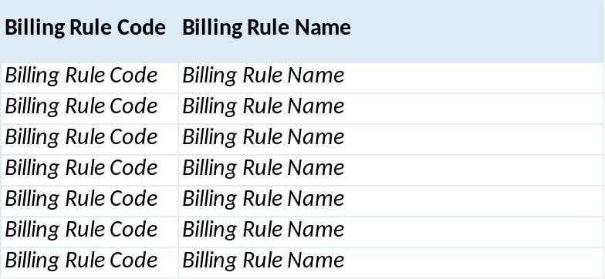

INPUT PARAMETER
Test
- CCOMPANY_ID
Company Id dari Login User

- CPROPERTY_ID
Selected Property Id

- CBILLING_RULE_TYPE
01 – Strata / 02 - Lease

- CUNIT_TYPE_CTG_ID
Selected Unit Type Category

- LACTIVE_ONLY
Active Only Flag

- USER_ID
Login User

BUTTON DEFINITION
Test
- OK
Tombol untuk mensubmit data yang terpilih ke form pemanggil
- Cancel
Tombol untuk membatalkan/menutup lookup

OUTPUT
Test

ROLES
Test
- Program ini tidak punya pengaturan hak akses sendiri, hak akses mengikut pada form pemanggil

INITIAL PROCESS
Test
- None

DISPLAY PROCESS
Test
Load Billing Rule Lookup List:

EXEC RSP_PM_GET_BILLING_RULE_LIST @CCOMPANY_ID, @CPROPERTY_ID, @CUSER_LOGIN_ID

- Dimana Set:
  - @COMPANY_ID = [COMPANY_ID]
  - @CPROPERTY_ID = [Selected Property Id]
  - @CBILLING_RULE_TYPE = 01 – Strata / 02 - Lease
  - @CUNIT_TYPE_CTG_ID = [Selected Unit Type Category]
  - @LACTIVE_ONLY = [Selected Active Only Flag]
  - @CUSER_LOGIN_ID = User Login Id

- Definisi Column: (Single Selection)
  - “Billing Rule Code"
    - Textbox
    - Display = CBILLING_RULE_CODE
  - "Billing Rule Name"
    - Textbox
    - Display = CBILLING_RULE_NAME
- Definisi Button:
  - OK
    - Onclick:
      - Validasi:
        - Harus ada 1 row yang terpilih, jika tidak tampilkan error message “Please select Billing Rule”
      - Kirim semua informasi Billing Rule yang terpilih ke form pemanggil:
        - CBILLING_RULE_CODE
        - CBILLING_RULE_NAME
      - Tutup form lookup
  - Cancel
    - Onclick: tutup form lookup

PML01100 – T & C LOOKUP

USER INTERFACE:
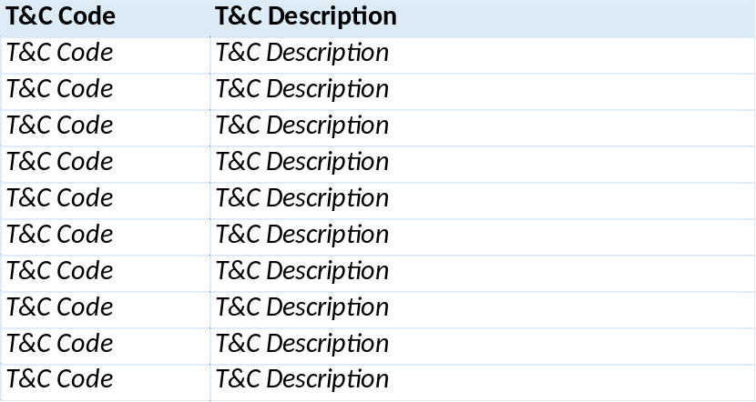

INPUT PARAMETER
Test
- CCOMPANY_ID
Company Id dari Login User

- CPROPERTY_ID
Selected Property Id

- USER_ID
Login User

BUTTON DEFINITION
Test
- OK
Tombol untuk mensubmit data yang terpilih ke form pemanggil
- Cancel
Tombol untuk membatalkan/menutup lookup

OUTPUT
Test

ROLES
Test
- Program ini tidak punya pengaturan hak akses sendiri, hak akses mengikut pada form pemanggil

INITIAL PROCESS
Test
- None

DISPLAY PROCESS
Test
Load T & C Lookup List:

EXEC RSP_PM_GET_TC_LIST @CCOMPANY_ID, @CPROPERTY_ID, @CUSER_LOGIN_ID

- Dimana Set:
  - @COMPANY_ID = [COMPANY_ID]
  - @CPROPERTY_ID = [Selected Property Id]
  - @CUSER_LOGIN_ID = User Login Id

- Definisi Column: (Single Selection)
  - “T&C Code"
    - Textbox
    - Display = CTC_CODE
  - "T&C Description"
    - Textbox
    - Display = CTC_NAME
- Definisi Button:
  - OK
    - Onclick:
      - Validasi:
        - Harus ada 1 row yang terpilih, jika tidak tampilkan error message “Please select T&C”
      - Kirim semua informasi T&C yang terpilih ke form pemanggil:
        - CTC_CODE
        - CTC_NAME
      - Tutup form lookup
  - Cancel
    - Onclick: tutup form lookup

PML01200 – INVOICE GROUP LOOKUP

USER INTERFACE

INITIAL VERSION
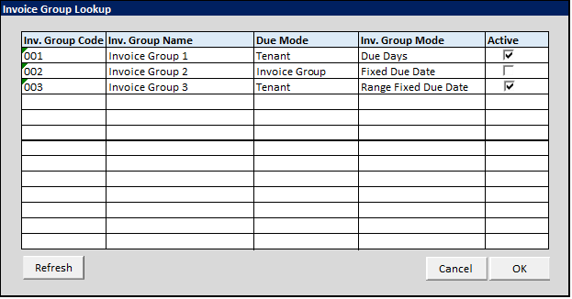

BUTTON DEFINITION
Button Name | Action
Refresh | Jalankan REFRESH PROCESS
OK | Jalankan SELECT DATA PROCESS
Cancel | Tutup Form

INPUT PARAMETER
Parameter Name | Description
CCOMPANY_ID | Company ID
CPROPERTY_ID | Property ID
CINVGRP_CODE | Invoice Group Code
CACTIVE_TYPE | Active Type(ALL, ACTIVE, INACTIVE)
CLANGUAGE_ID | Language ID

OUTPUT PARAMETER
Parameter Name | Description
CINVGRP_CODE | Invoice Group Code
CINVGRP_NAME | Department Code
CINVOICE_DUE_MODE | Invoice Due Mode Code
CINVOICE_DUE_MODE_NAME | Invoice Due Mode Name
CINVOICE_GROUP_MODE | Invoice Group Mode Code
CINVOICE_GROUP_MODE_NAME | Invoice Group Mode Name
LACTIVE | Active Flag

INITIAL PROCESS
Test
- Jalankan REFRESH PROCESS

DISPLAY PROCESS

FIELD DEFINITION
Name | Field | Type | Validation

INVOICE GROUP GRID DEFINITION
Name | Field | Type | Validation
Inv. Group Code | CALLOC_ID | Label
Inv. Group Name | CALLOC_NAME | Label
Due Mode | CDEPT_MODE_NAME | Label
Inv. Group Mode | CGLACCOUNT_NO –  CGLACCOUNT_NAME | Label
Active | LACTIVE | Checkbox
Grid Mode
- Read Only

BUTTON MODE
Button Name | Mode
Refresh | Enabled
OK | IF Grid not empty THEN Enabled ELSE Disabled
Cancel | Enabled

REFRESH PROCESS

VALIDATION
Field | Condition | Validation Message

ACTION
- Refresh Invoice Group Grid dengan RSP_PM_LOOKUP_INVOICE_GROUP dengan parameter
  - CCOMPANY_ID
  - CPROPERTY_ID
  - CINVGRP_CODE
  - CACTIVE_TYPE
  - CLANGUAGE_ID
- IF Grid empty,
  - Display message “No data found!”

SELECT DATA PROCESS

VALIDATION
Field | Condition | Validation Message

ACTION
- Return informasi selected row ke form pemanggil

PML01300 – LOI/AGREEMENT LOOKUP

USER INTERFACE

INITIAL VERSION
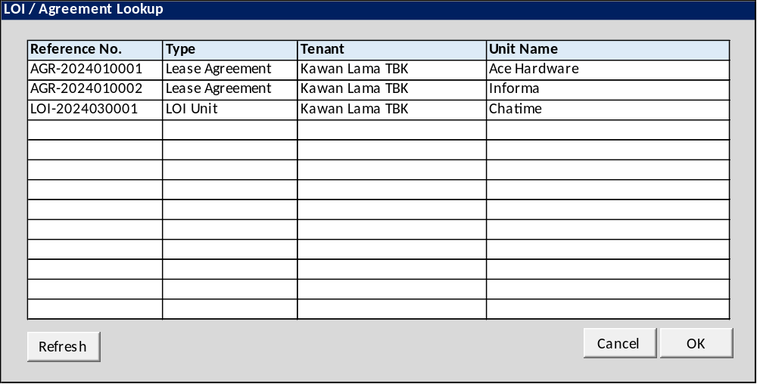

BUTTON DEFINITION
Button Name | Action
Refresh | Jalankan REFRESH PROCESS
OK | Jalankan SELECT DATA PROCESS
Cancel | Tutup Form

INPUT PARAMETER
Parameter Name | Description
CCOMPANY_ID | Company ID
CPROPERTY_ID | Property ID
CDEPT_CODE | Department Code
CLANGUAGE_ID | Language ID
CTENANT_ID | Tenant Id [CR17]

OUTPUT PARAMETER
Parameter Name | Description
CAGREEMENT_ID | LOI/Agreement Record ID
CREF_NO | LOI/Agreement No.
CTRANS_CODE | Transaction Code
CTRANSACTION_NAME | Transaction Name
CUNIT_DESCRIPTION | Unit Description
CTENANT_ID | Tenant ID
CTENANT_NAME | Tenant Name
CTENANT_TYPE_ID | Tenant Type ID
CTENANT_TYPE_NAME | Tenant Type Name
CCHARGE_MODE | Charge Mode (01=By Agreement, 02=By Unit)CR15

INITIAL PROCESS
Test
- Jalankan REFRESH PROCESS

DISPLAY PROCESS

FIELD DEFINITION
Name | Field | Type | Validation

LOI/AGREEMENT GRID DEFINITION
Name | Field | Type | Validation
Agreement ID | CAGREEMENT_ID | Hidden
Reference No. | CREF_NO | Label
Type | CTRANSACTION_NAME | Label
Tenant | CTENANT_NAME | Label
Unit Name | CUNIT_DESCRIPTION | Label
Grid Mode
- Read Only

BUTTON MODE
Button Name | Mode
Refresh | Enabled
OK | IF Grid not empty THEN Enabled ELSE Disabled
Cancel | Enabled

REFRESH PROCESS

VALIDATION
Field | Condition | Validation Message

ACTION
- Refresh Grid dengan RSP_PM_LOOKUP_INV_PLAN_AGREEMENT dengan parameter
  - CCOMPANY_ID
  - CPROPERTY_ID
  - CDEPT_CODE

  - CLANGUAGE_ID
  - CTENANT_ID [CR17]
- IF Grid empty,
  - Display message “No data found!”

SELECT DATA PROCESS

VALIDATION
Field | Condition | Validation Message

ACTION
- Return informasi selected row ke form pemanggil

PML01400 – AGREEMENT UNIT CHARGES LOOKUP

USER INTERFACE:
[CR18]

INPUT PARAMETER
Parameter Name | Description
CCOMPANY_ID | Company Id
CPROPERTY_ID | Property ID
CAGREEMENT_NO | Selected Agreement No
CUSER_ID | User Id

OUTPUT PARAMETER
Parameter Name | Description
CCOMPANY_ID
CPROPERTY_ID
CDEPT_CODE
CTRANS_CODE
CREF_NO
CBUILDING_ID
CFLOOR_ID
CUNIT_ID
CCHARGES_TYPE
CDESCRIPTION
CCHARGES_ID
CCHARGES_NAME
CSEQ_NO
CTAX_ID
CTAX_NAME
CSTART_DATE
CEND_DATE
CBILLING_MODE
CFEE_METHOD
NFEE_AMT
CINVOICE_PERIOD
CINVOICE_PERIOD_DESCR
IINTERVAL
NINVOICE_AMT
CDESCRIPTION
LCAL_UNIT
CCURRENCY_CODE
IYEARS
IMONTHS
IDAYS
NVGRP_CODE
NVGRP_NAME
LPRORATE
LBASED_OPEN_DATE
LTOTAL_PRICE
LOVERWRITE
NBOTTOM_PRICE
LACTIVE
CACTIVE_BY
DACTIVE_DATE
CINACTIVE_BY
DINACTIVE_DATE
CCREATE_BY
DCREATE_DATE
CUPDATE_BY
DUPDATE_DATE

BUTTON DEFINITION
Test
- OK
Tombol untuk mensubmit data yang terpilih ke form pemanggil
- Cancel
Tombol untuk membatalkan/menutup lookup

ROLES
Test
- Program ini tidak punya pengaturan hak akses sendiri, hak akses mengikut pada form pemanggil

INITIAL PROCESS
Test
- None

DISPLAY PROCESS
Test
Load Unit Charges Lookup List:

EXEC RSP_PM_GET_AGREEMENT_CHARGES_DT @CCOMPANY_ID, @CPROPERTY_ID, @CDEPT_CODE, @CTRANS_CODE, @CREF_NO, ‘’, @CUSER_LOGIN_ID

- Dimana Set:
  - @COMPANY_ID = [COMPANY_ID]
  - @CPROPERTY_ID = [Selected Property Id]
  - @CDEPT_CODE = [Selected Dept Cpde]
  - @CTRANS_CODE = [Selected Trans Code]
  - @CREF_NO = [Selected Ref No]
  - @CSEQ_NO = ‘’
  - @CUSER_LOGIN_ID = [USER_ID] [CR09]

- Definisi Column: (Single Selection)
  - "Charges Id"
    - Field: [CCHARGES_ID]
    - Label
  - "Charges Name"
    - Field: [CCHARGES_NAME]
    - Label

- Definisi Button:
  - OK
    - Onclick:
      - Validasi:
        - Harus ada 1 row yang terpilih, jika tidak tampilkan error message “Please select Unit Charges”
      - Kirim semua informasi Tax yang terpilih ke form pemanggil:
        - CCHARGES_ID
        - CCHARGES_NAME
        - CSTART_DATE
        - CEND_DATE
        - NINVOICE_AMT
      - Tutup form lookup
  - Cancel
    - Onclick: tutup form lookup

PML01500 – SLA Category Lookup

USER INTERFACE

INITIAL VERSION
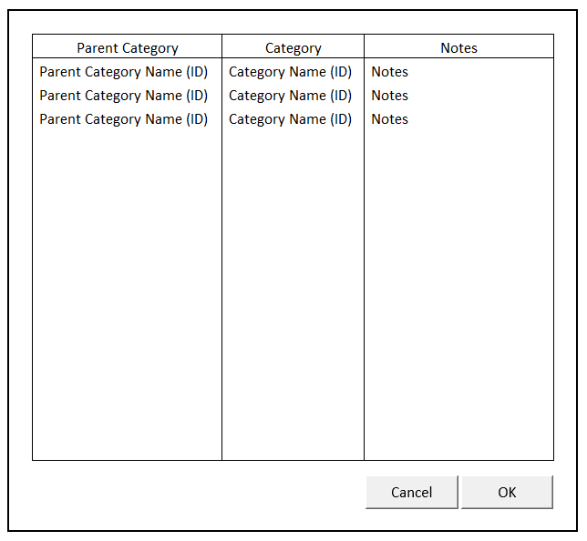

BUTTON DEFINITION
Button Name | Action
Cancel | Jalankan CANCEL PROCESS
OK | Jalankan PROCESS

INPUT PARAMETER
Parameter Name | Description
CPROPERTY_ID | Property Id
CCATEGORY_ID | Category Id

OUTPUT PARAMETER
Parameter Name | Description
CCOMPANY_ID | Company Id
CPROPERTY_ID | Property Id
CCATEGORY_ID | Category Id
CCATEGORY_NAME | Category Name
CPARENT_CATEGORY_ID | Parent’s Category Id
CPARENT_CATEGORY_NAME | Parent’s Category Name
ILEVEL | Tree Level
CNOTES | Notes or additional informations

INITIAL PROCESS
Test
- Load data from Input Parameter
- Set VAR_SELECTED_ASSIGN_SLA_CATEGORY NULL
- Set VAR_COMPANY_ID = Login User’s company id

- Load Assign SLA Category List
Jalankan RSP_PM_GET_ASSIGN_SLA_CATEGORY dengan parameter, simpan hasil ke VAR_ASSIGN_SLA_CATEGORY_LIST dan VAR_SELECTED_ASSIGN_SLA_CATEGORY
  - VAR_COMPANY_ID
  - CPROPERTY_ID

- Load Assign SLA Category Detail
Jalankan RSP_PM_GET_ASSIGN_SLA_CATEGORY dengan parameter, simpan hasil ke VAR_SELECTED_ASSIGN_SLA_CATEGORY:
  - VAR_COMPANY_ID
  - CPROPERTY_ID
  - VAR_SELECTED_ASSIGN_SLA_CATEGORY.CCATEGORY_ID

DISPLAY PROCESS

FIELD DEFINITION
Name | Field | Type | Validation
SLA Category Assign Grid |  | Data: VAR_ASSIGN_SLA_CATEGORY_LIST  IF VAR_ASSIGN_SLA_CATEGORY_LIST is NULL  - Show message “Please Add SLA Category information first” | Allow: -  ViewOnly  On Selected Changed,  Set VAR_SELECTED_ASSIGN_SLA_CATEGORY = Selected row data  Load Assign SLA Category Detail  Jalankan RSP_PM_GET_ASSIGN_SLA_CATEGORY dengan parameter:  - VAR_COMPANY_ID  - VAR_SELECTED_PROPERTY.CPROPERTY_ID  - VAR_SELECTED_ASSIGN_SLA_CATEGORY.CCATEGORY_ID
Parent Category | CPARENT_CATEGORY_NAME (CPARENT_CATEGORY_ID) | Textbox, Disabled
Category | CCATEGORY_NAME (CCATEGORY_ID) | Textbox, Disabled
Notes | CNOTES | Textbox, Disabled

CANCEL PROCESS

VALIDATION
Field | Condition | Validation Message

ACTION
- Close this Lookup

PROCESS

VALIDATION
Field | Condition | Validation Message

ACTION
- Close this Lookup
- Return informasi selected row ke form pemanggil

SELECT DATA PROCESS

VALIDATION
Field | Condition | Validation Message

ACTION
- Close this Lookup
- Return informasi selected row ke form pemanggil

PML01600 – SLA Call Type Lookup

USER INTERFACE

INITIAL VERSION
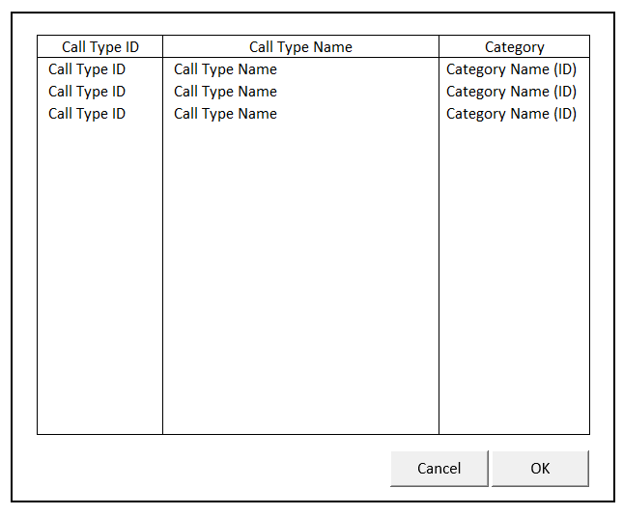

BUTTON DEFINITION
Button Name | Action
Cancel | Jalankan CANCEL PROCESS
OK | Jalankan PROCESS

INPUT PARAMETER
Parameter Name | Description
CPROPERTY_ID | Property Id
CCALL_TYPE_ID | Call Type Id

OUTPUT PARAMETER
Parameter Name | Description
CCOMPANY_ID | Company Id
CPROPERTY_ID | Property Id
CCALL_TYPE_ID | Call Type Id
CCALL_TYPE_NAME | Call Type Name
CCATEGORY_ID | Category Id
CCATEGORY_NAME | Category Name
IDAYS | Days of work completion
IHOURS | Hours of work completion
IMINUTES | Minutes of work completion
LPRIORITY | Link to priority apps

INITIAL PROCESS
Test
- Load data from Input Parameter
- Set VAR_SELECTED_SLA_CALL_TYPE NULL
- Set VAR_COMPANY_ID = Login User’s company id

- Load SLA Call Type List
Jalankan RSP_PM_GET_SLA_CALL_TYPE_LIST dengan parameter, simpan hasil ke VAR_SLA_CALL_TYPE_LIST dan VAR_SELECTED_SLA_CALL_TYPE
  - VAR_COMPANY_ID
  - CPROPERTY_ID

- Load SLA Call Type Detail
Jalankan RSP_PM_GET_SLA_CALL_TYPE_LIST dengan parameter, simpan hasil ke VAR_SELECTED_SLA_CALL_TYPE:
  - VAR_COMPANY_ID
  - CPROPERTY_ID
  - VAR_SELECTED_SLA_CALL_TYPE.CCATEGORY_ID

DISPLAY PROCESS

FIELD DEFINITION
Name | Field | Type | Validation
SLA Category Assign Grid |  | Data: VAR_SLA_CALL_TYPE_LIST  IF VAR_SLA_CALL_TYPE_LIST is NULL  - Show message “Please Add SLA Call Type information first” | Allow: -  ViewOnly  On Selected Changed,  Set VAR_SELECTED_SLA_CALL_TYPE = Selected row data  Load SLA Call Type Detail  Jalankan RSP_PM_GET_ASSIGN_SLA_CATEGORY dengan parameter:  - VAR_COMPANY_ID  - VAR_SELECTED_PROPERTY.CPROPERTY_ID  - VAR_SELECTED_SLA_CALL_TYPE.CCALL_TYPE_ID
Call Type ID | CCALL_TYPE_ID | Textbox, Disabled
Call Type Name | CCALL_TYPE_NAME | Textbox, Disabled
Category | CCATEGORY_NAME (CCATEGORY_ID) | Textbox, Disabled

CANCEL PROCESS

VALIDATION
Field | Condition | Validation Message

ACTION
- Close this Lookup

PROCESS

VALIDATION
Field | Condition | Validation Message

ACTION
- Close this Lookup
- Return informasi selected row ke form pemanggil

SELECT DATA PROCESS

VALIDATION
Field | Condition | Validation Message

ACTION
- Close this Lookup
- Return informasi selected row ke form pemanggil

PML01700 – CANCEL RECEIPT FROM CUSTOMER LOOKUP

USER INTERFACE

INITIAL VERSION
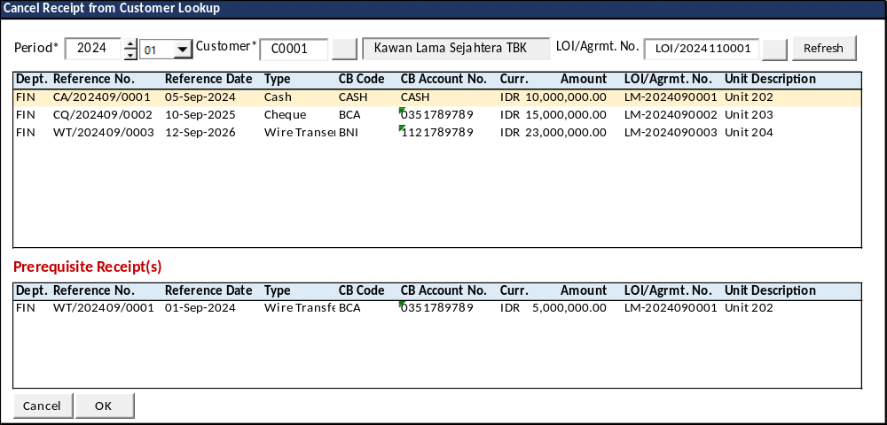

BUTTON DEFINITION
Button Name | Action
Refresh | Jalankan REFRESH PROCESS
OK | Jalankan SELECT DATA PROCESS
Cancel | Tutup Form

INPUT PARAMETER
Parameter Name | Description
CCOMPANY_ID | Company ID
CPROPERTY_ID | Property ID
CUSER_ID | User ID
CLANGUAGE_ID | Language ID
CDEPT_CODE | Department Code CR22

OUTPUT PARAMETER
Parameter Name | Description
CPROPERTY_NAME | Property Name
CDEPT_CODE | Department Code
CDEPT_NAME | Department Name
CTRANS_CODE | Transaction Code
CREF_NO | Reference No
CREC_ID | Record ID
CREF_DATE | Reference Date
CREF_PRD | Reference Period
CTENANT_ID | Tenant ID
CTENANT_NAME | Tenant Name
CDOC_NO | Document No.
CDOC_DATE | Document Date
CCURRENCY_CODE | Currency Code
CCURRENCY_NAME | Currency Name
NTRANS_AMOUNT | Receipt Amount
CTRANS_STATUS | Status Code
CTRANS_STATUS_NAME | Status Name
CCHEQUE_STATUS | Cheque Status Code
CCHEQUE_STATUS_NAME | Cheque Status Name
CTRANS_DESC | Transaction Description
CDUE_DATE | Cheque Due Date
CPAYMENT_TYPE | Payment Type
CPAYMENT_TYPE_NAME | Payment Type Name
CCB_CODE | Cash Bank Code
CCB_NAME | Cash Bank Name
CCB_ACCOUNT_NO | Cash Bank Account No.
CCB_ACCOUNT_NAME | Cash Bank Account Name
CUNIT_DESCRIPTION | Unit Description
CLOI_AGRMT_ID | LOI/Agreement Record ID
CLOI_AGRMT_NO | LOI/Agreement No

INITIAL PROCESS
Test
- Jalankan RSP_GS_GET_PERIOD_YEAR_RANGE dengan parameter, simpan hasil ke VAR_GSM_PERIOD
  - CCOMPANY_ID
  - ‘’ (Empty String)
  - ‘’ (Empty String)

DISPLAY PROCESS

FIELD DEFINITION
Name | Field | Type | Validation
Period (Year) |  | Spinner  - Minimum Value = VAR_GSM_PERIOD.IMIN_YEAR  - Minimum Value = VAR_GSM_PERIOD.IMAX_YEAR  - Stepping value = 1  Set Default selected value = Current Year
Period (Month) |  | Combobox  Isi combo box value dengan  01 s/d 12  Set Default selected value = Current Month
Customer |  | Lookup | - Mandatory  - Lookup dengan program PML00600 TENANT LOOKUP  - Lookup parameter  - CCOMPANY_ID  - CPROPERTY_ID  - ‘’  - CUSER_ID  - Hasil Lookup  - Set Customer ID = CTENANT_ID  - Set Customer Name = CTENANT_NAME  - Set Customer Type=CTENANT_TYPE_NAME  - On value changed  - Reset LOI/Agrmt. Dept. and LOI/Agrmnt. No.
Customer Name | CCUST_SUPP_NAME | Textbox, disabled
LOI/Agrmt. No. |  | Lookup | - Maximum 30 characters  - Lookup dengan program PML00800 AP SCHEDULED PAYMENT LOOKUP  - Lookup parameter  - CCOMPANY_ID  - CPROPERTY_ID  - ‘’  - ‘’  - VAR_LANGUAGE_ID  - 991000  - ‘’  - Selected Customer ID  - ‘’  - 30,80  - ‘’  - Hasil Lookup  - Set LOI/Agrmt. No = CREF_NO  - Set LOI/Agrmt. ID = CREC_ID  - Set Loi/Agrmt. Dept. Code=CDEPT_CODE  - Set Loi/Agrmt. Dept. Name=CDEPT_NAME
LOI/Agrmt. ID
LOI/Agrmt. Dept. Code
LOI/Agrmt. Dept. Name

RECEIPT GRID DEFINITION
Name | Field | Type | Validation
Receipt ID | CREC_ID | Hidden
Dept. | CDEPT_CODE | Label
Reference No. | CREF_NO | Label
Reference Date | CREF_DATE | Label
Type | CPAYMENT_TYPE_NAME | Label
CB Code | CCB_CODE | Label
CB Account No. | CCB_ACCOUNT_NO | Label
Curr. | CCURRENCY_CODE | Label
Amount | NTRANS_AMOUNT | Label
LOI/Agrmt. No. | CLOI_AGRMT_NO | Label
Unit Description | CUNIT_DESCRIPTION | Label
Grid Mode
- Read Only

On selected row changed
- Jalankan REFRESH PREREQUISITE PROCESS

PREREQUISITE GRID DEFINITION
Name | Field | Type | Validation
Receipt ID | CREC_ID | Hidden
Dept. | CDEPT_CODE | Label
Reference No. | CREF_NO | Label
Reference Date | CREF_DATE | Label
Type | CPAYMENT_TYPE_NAME | Label
CB Code | CCB_CODE | Label
CB Account No. | CCB_ACCOUNT_NO | Label
Curr. | CCURRENCY_CODE | Label
Amount | NTRANS_AMOUNT | Label
LOI/Agrmt. No. | CLOI_AGRMT_NO | Label
Unit Description | CUNIT_DESCRIPTION | Label
Grid Mode
- Read Only

BUTTON MODE
Button Name | Mode
Refresh | Enabled
OK | IF Grid not empty THEN Enabled ELSE Disabled
Cancel | Enabled

REFRESH PROCESS

VALIDATION
Field | Condition | Validation Message
Customer | Empty | Please select Customer!

ACTION
- Refresh Reference No. Grid dengan RSP_PM_LOOKUP_CANCEL_CUST_RECEIPT dengan parameter
  - CCOMPANY_ID
  - CPROPERTY_ID
  - CUSER_ID
  - Selected period with yyyymm format
  - Selected Customer ID
  - Selected LOI/Agrmt. ID
  - CLANGUAGE_ID
  - CDEPT_CODE CR22
- IF Grid empty,
  - Display message “No data found!”
- ELSE
  - Jalankan REFRESH PREREQUISITE PROCESS

REFRESH PREREQUISITE PROCESS

VALIDATION
Field | Condition | Validation Message

ACTION
- Refresh Prerequisite Grid dengan RSP_PM_GET_PREREQUISITE_CUST_RECEIPT_LIST dengan parameter
  - CCOMPANY_ID
  - Selected Receipt ID
  - CLANGUAGE_ID

SELECT DATA PROCESS

VALIDATION
Field | Condition | Validation Message
Prerequisite Grid | Not Empty | Selected Receipt is not valid for Cancellation as it has prerequisite Receipt(s) required to cancel first!

ACTION
- Return informasi selected row ke form pemanggil

PML01800 – Unit Tenant Lookup

USER INTERFACE

INITIAL VERSION
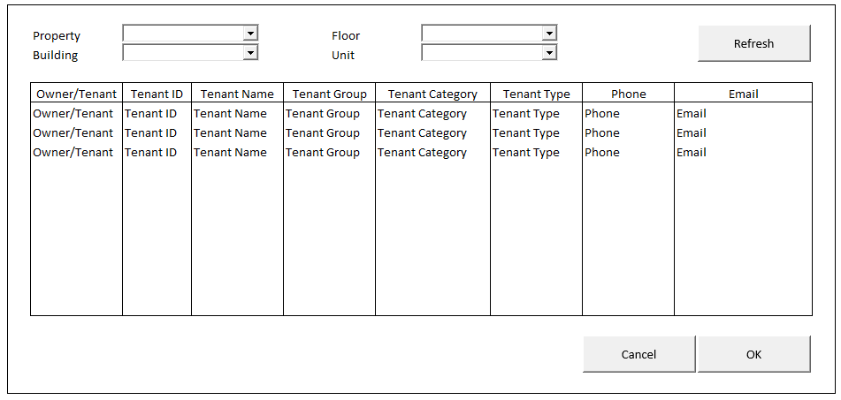

BUTTON DEFINITION
Button Name | Action
Refresh | Jalankan REFRESH PROCESS
Cancel | Jalankan CANCEL PROCESS
OK | Jalankan PROCESS

INPUT PARAMETER
Parameter Name | Description
CCOMPANY_ID | Company Id
CPROPERTY_ID | Property Id
CBUILDING_ID | Building Id
CFLOOR_ID | Floor Id
CUNIT_ID | Unit Id
CUSER_ID | User Id
CLANG_ID | Language Id
CSEARCH_TEXT | → Search CTENANT_ID

OUTPUT PARAMETER
Parameter Name | Description
CCOMPANY_ID | Company Id
CPROPERTY_ID | Property Id
CBUILDING_ID | Building Id
CFLOOR_ID | Floor Id
CUNIT_ID | Unit Id
CTENANT_ID | Tenant Id
CTENANT_NAME | Tenant Name
CPHONE1 | Phone
CEMAIL | Email
CTENANT_GROUP_ID | Tenant Group Id
CTENANT_GROUP_NAME | Tenant Group Name
CTENANT_CATEGORY_ID | Tenant Category Id
CTENANT_CATEGORY_NAME | Tenant Category Name
CTENANT_TYPE_ID | Tenant Type Id
CTENANT_TYPE_DESCRIPTION | Tenant Type Description
COWNER_OR_TENANT | Owner/Tenant

INITIAL PROCESS
Test
- Load data from Input Parameter
- Set VAR_SELECTED_UNIT_TENANT NULL

- Load Property List
Jalankan RSP_GS_GET_PROPERTY_LIST dengan parameter, simpan hasil ke VAR_PROPERTY_LIST
  - CCOMPANY_ID
  - CUSER_ID

- IF CPROPERTY_ID is not EMPTY, then set VAR_SELECTED_PROPERTY = CPROPERTY_ID
Else, set VAR_SELECTED_PROPERTY = VAR_PROPERTY_LIST’s first item.

- Load Building List
Jalankan RSP_GS_GET_BUILDING_LIST dengan parameter, simpan hasil ke VAR_BUILDING_LIST
  - CCOMPANY_ID
  - VAR_SELECTED_PROPERTY.CPROPERTY_ID
  - CUSER_ID

- IF CBUILDING_ID is not EMPTY, then set VAR_SELECTED_BUILDING = CBUILDING_ID
Else, set VAR_SELECTED_BUILDING = VAR_BUILDING_LIST’s first item.

- Load Floor List
Jalankan RSP_GS_GET_BUILDING_FLOOR_LIST dengan parameter, simpan hasil ke VAR_FLOOR_LIST
  - CCOMPANY_ID
  - VAR_SELECTED_PROPERTY.CPROPERTY_ID
  - VAR_SELECTED_BUILDING.CBUILDING_ID
  - CUSER_ID

- IF CFLOOR_ID is not EMPTY, then set VAR_SELECTED_BUILDING = CFLOOR_ID
Else, set VAR_SELECTED_FLOOR = VAR_FLOOR_LIST’s first item.

- Load Unit List
Jalankan RSP_GS_GET_BUILDING_UNIT_LIST dengan parameter, simpan hasil ke VAR_UNIT_LIST
  - CCOMPANY_ID
  - VAR_SELECTED_PROPERTY.CPROPERTY_ID
  - VAR_SELECTED_BUILDING.CBUILDING_ID
  - VAR_SELECTED_FLOOR.CFLOOR_ID
  - CUSER_ID

- IF CUNIT_ID is not EMPTY, then set VAR_SELECTED_UNIT = CUNIT_ID
Else, set VAR_SELECTED_UNIT = VAR_UNIT_LIST’s first item.

- Load Unit Tenant List
Jalankan RSP_PM_GET_UNIT_TENANT_LIST dengan parameter, simpan hasil ke VAR_UNIT_TENANT_LIST dan VAR_SELECTED_UNIT_TENANT
  - CCOMPANY_ID
  - VAR_SELECTED_PROPERTY.CPROPERTY_ID
  - VAR_SELECTED_BUILDING.CBUILDING_ID
  - VAR_SELECTED_FLOOR.CFLOOR_ID
  - VAR_SELECTED_UNIT.CUNIT_ID
  - CUSER_ID
  - CLANG_ID
  - ‘’

- Get CSEARCH_TEXT data
Jalankan RSP_PM_GET_UNIT_TENANT_LIST dengan parameter, simpan hasil ke VAR_SELECTED_UNIT_TENANT:
  - CCOMPANY_ID
  - VAR_SELECTED_PROPERTY.CPROPERTY_ID
  - VAR_SELECTED_BUILDING.CBUILDING_ID
  - VAR_SELECTED_FLOOR.CFLOOR_ID
  - VAR_SELECTED_UNIT.CUNIT_ID
  - CUSER_ID
  - CLANG_ID
  - CSEARCH_TEXT

DISPLAY PROCESS

FIELD DEFINITION
Name | Field | Type | Validation
Property | VAR_SELECTED_PROPERTY | Combobox  Isi combobox dengan VAR_PROPERTY_LIST  Set ValueField = CPROPERTY_ID  Set TextField = CPROPERTY_NAME  Simpan hasil ke VAR_SELECTED_PROPERTY | On Value Changed,  Load Buiding List (See INITIAL PROCESS)  Load Floor List (See INITIAL PROCESS)  Load Unit List (See INITIAL PROCESS)
Building | VAR_SELECTED_BUILDING | Combobox  Isi combobox dengan VAR_BUILDING_LIST  Set ValueField = CBUILDING_ID  Set TextField = CBUILDING_NAME  Simpan hasil ke VAR_SELECTED_BUILDING | On Value Changed,  Load Floor List (See INITIAL PROCESS)  Load Unit List (See INITIAL PROCESS)
Floor | VAR_SELECTED_FLOOR | Combobox  Isi combobox dengan VAR_FLOOR_LIST  Set ValueField = CFLOOR_ID  Set TextField = CFLOOR_NAME  Simpan hasil ke VAR_SELECTED_FLOOR | On Value Changed,  Load Unit List (See INITIAL PROCESS)
Unit | VAR_SELECTED_UNIT | Combobox  Isi combobox dengan VAR_UNIT_LIST  Set ValueField = CUNIT_ID  Set TextField = CUNIT_NAME  Simpan hasil ke VAR_SELECTED_UNIT
Unit Tenant Grid |  | Data: VAR_UNIT_TENANT_LIST  Type: Original | Allow: -  ViewOnly  On Selected Changed,  Set VAR_SELECTED_UNIT_TENANT = Selected row data
Owner/Tenant | COWNER_OR_TENANT | Textbox, Disabled
Tenant Id | CTENANT_ID | Textbox, Disabled
Tenant Name | CTENANT_NAME | Textbox, Disabled
Tenant Group | CTENANT_GROUP_NAME | Textbox, Disabled
Tenant Category | CTENANT_CATEGORY_NAME | Textbox, Disabled
Tenant Type | CTENANT_TYPE_DESCRIPTION | Textbox, Disabled
Phone | CPHONE1 | Textbox, Disabled
Email | CEMAIL | Textbox, Disabled

REFRESH PROCESS

VALIDATION
Field | Condition | Validation Message
Property | VAR_SELECTED_PROPERTY is Empty | Property is empty!
Building | VAR_SELECTED_BUILDING is Empty | Building is empty!
Floor | VAR_SELECTED_FLOOR is Empty | Floor is empty!
Unit | VAR_SELECTED_UNIT is Empty | Unit is empty!

ACTION
- Validate (See VALIDATION table)
IF Success, jalankan Load Unit Tenant List
IF Failed, show error

- Load Unit Tenant List
Jalankan RSP_PM_GET_UNIT_TENANT_LIST dengan parameter, simpan hasil ke VAR_UNIT_TENANT_LIST dan VAR_SELECTED_UNIT_TENANT
  - CCOMPANY_ID
  - VAR_SELECTED_PROPERTY.CPROPERTY_ID
  - VAR_SELECTED_BUILDING.CBUILDING_ID
  - VAR_SELECTED_FLOOR.CFLOOR_ID
  - VAR_SELECTED_UNIT.CUNIT_ID
  - CUSER_ID
  - CLANG_ID
  - ‘’

CANCEL PROCESS

VALIDATION
Field | Condition | Validation Message

ACTION
- Close this Lookup

PROCESS

VALIDATION
Field | Condition | Validation Message

ACTION
- Close this Lookup
- Return informasi selected row ke form pemanggil

SELECT DATA PROCESS

VALIDATION
Field | Condition | Validation Message

ACTION
- Close this Lookup
- Return informasi selected row ke form pemanggil

PML01900 – Staff Lookup

USER INTERFACE

INITIAL VERSION
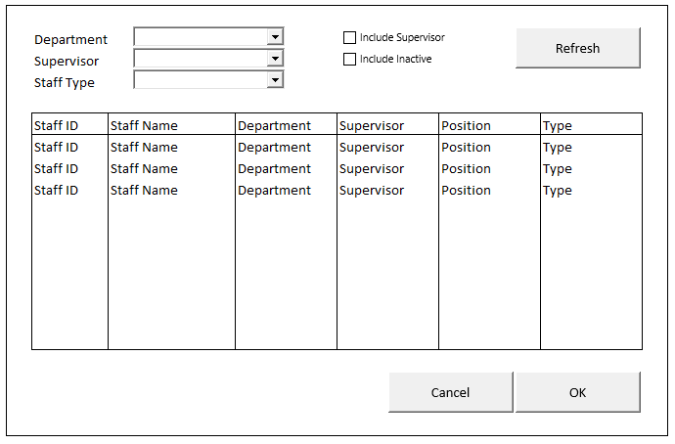

BUTTON DEFINITION
Button Name | Action
Refresh | Jalankan REFRESH PROCESS
Cancel | Jalankan CANCEL PROCESS
OK | Jalankan PROCESS

INPUT PARAMETER
Parameter Name | Description
CCOMPANY_ID | Company Id
CPROPERTY_ID | Property Id
CSUPERVISOR_ID | Multiple Supervisor ID (join by “,”)
LSUPERVISOR | 0 – does not include supervisor , 1 – include supervisor
CDEPT_CODE | Multiple Dept Code (join by “,”)
CACTIVE_INACTIVE | 0 – ALL, 1 – Active Only, 2 – Inactive Only
CSTAFF_TYPE | ‘00’ – ALL
CUSER_ID | User Id
CLANG_ID | Language Id
CSEARCH_TEXT | → Search CSTAFF_ID

OUTPUT PARAMETER
Parameter Name | Description
CCOMPANY_ID | Company Id
CPROPERTY_ID | Property Id
CSTAFF_ID | Staff Id
CSTAFF_NAME | Staff Name
CDEPT_CODE | Department
CSUPERVISOR | Supervisor Id
CSUPERVISOR_NAME | Supervisor Name
CPOSITION | Position
CPOSITION_DESCRIPTION | Position Description
CTYPE | Type
CTYPE_DESCRIPTION | Type Description
CEMAIL | Email
CMOBILE_PHONE1 | Phone 1
LACTIVE | Active

INITIAL PROCESS
Test
- Load data from Input Parameter
- Set VAR_SELECTED_STAFF NULL
- Set VAR_INCLUDE_INACTIVE_CHECKBOX = FALSE

- IF CACTIVE_INACTIVE is not EMPTY, then set VAR_ACTIVE_INACTIVE = CACTIVE_INACTIVE
Else, set VAR_ACTIVE_INACTIVE = 1

- Set VAR_INCLUDE_SUPERVISOR = LSUPERVISOR

- Load Department List
Jalankan RSP_GS_GET_DEPT_LIST dengan parameter, simpan hasil ke VAR_DEPT_LIST
  - CCOMPANY_ID
  - CUSER_ID

- IF CDEPT_CODE is not EMPTY, then set VAR_SELECTED_DEPT = CDEPT_CODE
Else, set VAR_SELECTED_DEPT = VAR_DEPT_LIST’s first item.

- Load Supervisor List
Jalankan RSP_PM_GET_SUPERVISOR_LOOKUP_LIST dengan parameter, simpan hasil ke VAR_SUPERVISOR_LIST
  - CCOMPANY_ID
  - CPROPERTY_ID
  - CUSER_ID

- IF CSUPERVISOR_ID is not EMPTY, then set VAR_SELECTED_SUPERVISOR = CSUPERVISOR_ID
Else, set VAR_SELECTED_SUPERVISOR = VAR_SUPERVISOR_LIST’s first item.

- Load Staff Type
Jalankan RSP_GS_GET_GSB_CODE_LIST dengan parameter, simpan hasil ke VAR_STAFF_TYPE_LIST
  - ‘BIMASAKTI’
  - CCOMPANY_ID
  - ‘_BS_STAFF_TYPE’
  - VAR_LANG_ID

- IF CSTAFF_TYPE is not EMPTY, then set VAR_SELECTED_STAFF_TYPE = CSTAFF_TYPE_ID
Else, set VAR_SELECTED_STAFF_TYPE = VAR_STAFF_TYPE_LIST’s first item.

- Load Staff List
Jalankan RSP_PM_GET_STAFF_LOOKUP_LIST dengan parameter, simpan hasil ke VAR_STAFF_LIST dan VAR_SELECTED_STAFF
  - CCOMPANY_ID
  - CPROPERTY_ID
  - VAR_SELECTED_SUPERVISOR.CSUPERVISOR_ID
  - VAR_INCLUDE_SUPERVISOR
  - VAR_SELECTED_DEPT.CDEPT_CODE
  - VAR_ACTIVE_INACTIVE
  - VAR_SELECTED_STAFF_TYPE.CCODE
  - CUSER_ID
  - CLANG_ID
  - ‘’

- Get CSEARCH_TEXT data
Jalankan RSP_PM_GET_STAFF_LOOKUP_LIST dengan parameter, simpan hasil ke VAR_SELECTED_STAFF
  - CCOMPANY_ID
  - CPROPERTY_ID
  - VAR_SELECTED_SUPERVISOR.CSUPERVISOR_ID
  - VAR_INCLUDE_SUPERVISOR
  - VAR_SELECTED_DEPT.CDEPT_CODE
  - VAR_ACTIVE_INACTIVE
  - VAR_SELECTED_STAFF_TYPE.CCODE
  - CUSER_ID
  - CLANG_ID
  - CSEARCH_TEXT

DISPLAY PROCESS

FIELD DEFINITION
Name | Field | Type | Validation
Department | VAR_SELECTED_DEPT | Combobox  Isi combobox dengan VAR_DEPT_LIST  Set ValueField = CDEPT_CODE  Set TextField = CDEPT_NAME  Simpan hasil ke VAR_SELECTED_DEPT | On Value Changed,  Load Supervisor List (See INITIAL PROCESS)  IF CDEPT_CODE has “,”, then  Set Combobox DISABLED
Supervisor | VAR_SELECTED_SUPERVISOR | Combobox  Isi combobox dengan VAR_SUPERVISOR_LIST  Set ValueField = CSUPERVISOR  Set TextField = CSUPERVISOR_NAME  Simpan hasil ke VAR_SELECTED_SUPERVISOR | On Value Changed,  IF CSUPERVISOR_ID has “,”, then  Set Combobox DISABLED
Include Supervisor | VAR_INCLUDE_SUPERVISOR | Checkbox
Include Inactive | VAR_INCLUDE_INACTIVE_CHECKBOX | Checkbox | On Value Changed,  If VAR_INCLUDE_INACTIVE_CHECKBOX changed to CHECKED, then  VAR_ACTIVE_INACTIVE = 0  Else If VAR_INCLUDE_INACTIVE_CHECKBOX changed to UNCHECKED, then  VAR_ACTIVE_INACTIVE = 1
Staff Grid |  | Data: VAR_STAFF_LIST  Type: Original | Allow: -  ViewOnly  On Selected Changed,  Set VAR_SELECTED_STAFF = Selected row data
Staff ID | CSTAFF_ID | Textbox, Disabled
Staff Name | CSTAFF_NAME | Textbox, Disabled
Department | CDEPT_CODE | Textbox, Disabled
Supervisor | CSUPERVISOR | Textbox, Disabled
Position | CPOSITION_DESCRIPTION | Textbox, Disabled
Type | CTYPE_DESCRIPTION | Textbox, Disabled
Phone | CMOBILE_PHONE1 | Textbox, Disabled
Email | CEMAIL | Textbox, Disabled

REFRESH PROCESS

VALIDATION
Field | Condition | Validation Message

ACTION
- Validate (See VALIDATION table)
IF Success, jalankan Load Staff List
IF Failed, show error

- Load Staff List
Jalankan RSP_PM_GET_STAFF_LOOKUP_LIST dengan parameter, simpan hasil ke VAR_STAFF_LIST dan VAR_SELECTED_STAFF
  - CCOMPANY_ID
  - CPROPERTY_ID
  - VAR_SELECTED_SUPERVISOR.CSUPERVISOR_ID
  - VAR_INCLUDE_SUPERVISOR
  - VAR_SELECTED_DEPT.CDEPT_CODE
  - VAR_ACTIVE_INACTIVE
  - VAR_SELECTED_STAFF_TYPE.CCODE
  - CUSER_ID
  - CLANG_ID
  - ‘’

CANCEL PROCESS

VALIDATION
Field | Condition | Validation Message

ACTION
- Close this Lookup

PROCESS

VALIDATION
Field | Condition | Validation Message

ACTION
- Close this Lookup
- Return informasi selected row ke form pemanggil

SELECT DATA PROCESS

VALIDATION
Field | Condition | Validation Message

ACTION
- Close this Lookup
- Return informasi selected row ke form pemanggil

CR List
No | Note | Date
CR01  RE, 19 June 2023 | - Menambah Lookup PML00300 – Supervisor Lookup  - Menambah Lookup PML00400 – Utility Lookup
CR02  RE, 9 Jan 2024 | - Menambah Lookup PML00600 – Tenant Lookup
CR03  RE, 22 Feb 2024 | - Menambah Lookup PML00700 – Discount Lookup
CR04  CH, 14 May 2024 | - Menambah Lookup PML00800 – Aggrement No Lookup
CR05  CH, 15 May 2024 | - Menambah param dan output PML00200
CR06  CH, 21 May 2024 | - Menambah Lookup PML00900 – PM Transaction Lookup
CR07  IB, 27 May 2024 | - Menambah PML01000 – Billing Rule Lookup  - Menambah PML01100 – T&C Lookup
CR08  SG, 28 May 2024 | - Menambah PML01200 – Invoice Group Lookup
CR09  CH, 11 June 2024 | - Tambah param PML00200  - Tambah param dan output PML00400
CR10  SG, 15 June 2024 | - Menambah PML01300 – LOI/Agreement Lookup
CR11  CH, 24 June 2024 | - Tambah 7 output PML00600
CR12  CH, 26 June 2024 | - Tambah Input Param baru PML00800  - Tambah Output baru PML00800
CR13  SG, 22 August 2024 | - Tambah output param PML00900
CR14  CH, 18 Sept 2024 | - Tambah output PML00200
CR15  SG, 01 Oct 2024 | - Tambah output PML01300
CR16  RE, 3 Okt 2024 | - Tambah input parameter PML00500 - Salesman Lookup
CR17  RE, 8 Okt 2024 | - Tambah input parameter PML01300 – LOI / Agreement Lookup  - Tambah input parameter PML00200 – Unit Charges
CR18  RE, 26 Okt 2024 | - Tambah lookup PML01400 – Agreement Unit Charges Lookup
CR19  CH, 14 NOV 2024 | - Tambah param CUSER_ID di PML00800
CR20  NS, 22 Nov 2024 | - Menambahkan PML01500 – SLA Category Lookup  - Menambahkan PML01600 – SLA Call Type Lookup
CR21  SG, 28 Nov 2024 | - Menambahkan PML01700 – Cancel Receipt from Customer Lookup
CR22  SG, 10 Dec 2024 | - Tambah param CDEPT_CODE di PML01700
CR23  NS, 25 Dec 2024 | - Menambahkan PML01800 – Unit Tenant Lookup  - Menambahkan PML01900 – Staff Lookup
CR24  RE, 25 Apr 2025 | - Menambahkan input dan output parameter untuk Lookup PML00300 – Supervisor Lookup
CR25  SG, 25 Apr 2025 | - Revisi PML00900 – Tambah kolom Trans Amount dan ubah urutan kolom di grid

